
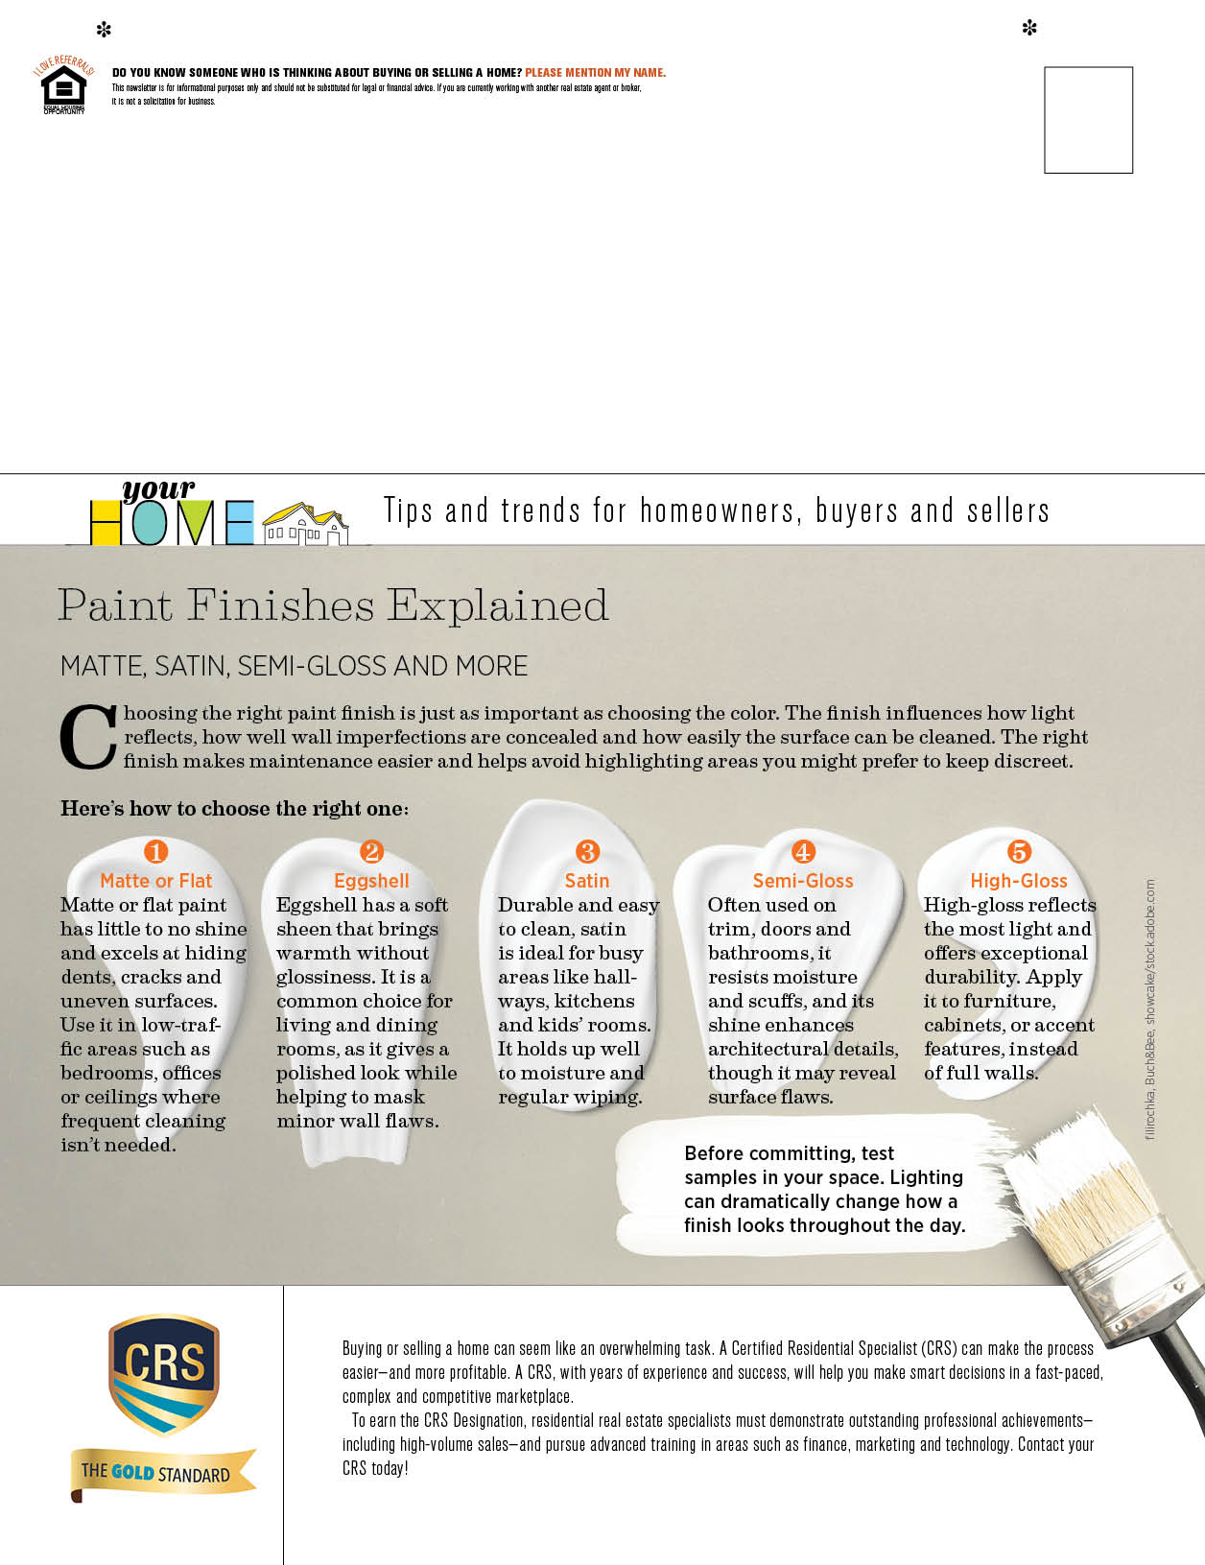
NAME
ADDRESS
ADDRESS
PHONE | WEBSITE | EMAIL
NAME
ADDRESS
ADDRESS
PHONE | WEBSITE | EMAIL
NAME
ADDRESS
ADDRESS
PHONE | WEBSITE | EMAIL

