# Tips and trends for homeowners, buyers and sellers

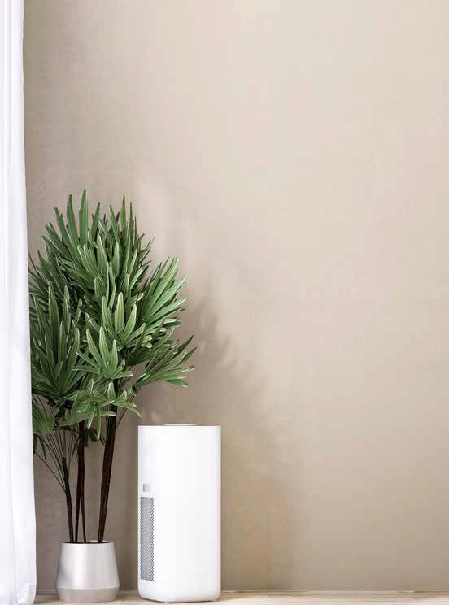

Improve Indoor Air Quality in Your Home

I

1

# How to Remove Wallpaper

Removing wallpaper may seem like a daunting task, but with the right tools and techniques, you can have smooth, clean walls ready for

ndoor air quality is essential for a healthy home environment.

Poor air quality can lead to allergies, respiratory issues and other health problems. Here are a few ways homeowners can

improve the air inside their homes.

Ventilate your space: Open

windows and doors whenever possible to allow fresh air to circulate and remove indoor pollutants. In colder months, use exhaust fans in kitchens and bathrooms to maintain airflow and reduce moisture buildup.

2

Change HVAC filters: Heating and cooling systems can trap

dust, pollen and other airborne particles. Replacing HVAC fil- ters regularly—about every 1–3 months—ensures your system is circulating clean air.

3

Add houseplants: Certain houseplants, such as spider and

snake plants, naturally filter air by removing toxins like formaldehyde, benzene and carbon monoxide.

4

Use an air purifier: Air purifiers with HEPA filters can help

remove allergens, dust, pet dander and other contaminants from the air—especially helpful in homes with allergy sufferers.

5

Reduce chemical pollutants:

Avoid using harsh cleaning

iStock.com/ Suchada Tansirima, Solovyova

fresh paint or new wallpaper. Here’s a step- by-step guide to make the process easier.

Start by preparing the area. Remove

furniture, cover the floor with drop cloths and use painter’s tape to protect woodwork. Test a small wallpaper section to see if it peels away easily. If it does, you may be able to remove the wallpaper without much effort. For stub- born wallpaper, more effort may be necessary.

Use a wallpaper scoring tool to lightly perforate the surface, allowing moisture to penetrate and loosen the adhesive.

Mix a wallpaper removal solution using warm water and a few drops of dish soap or a commercial wallpaper remover.

Spray or sponge the solution onto the wallpaper, ensuring it soaks through the paper but doesn’t oversaturate the walls.

After letting the solution sit for 10–15 minutes, gently scrape off the wallpaper using a plastic scraper or putty knife, starting from the bottom and working upward. Be careful not to damage the wall underneath.

Once the wallpaper is removed, wipe down the walls to remove any leftover

adhesive. Allow the walls to dry completely before painting or redecorating.

products, aerosol sprays and air fresheners that release volatile organic compounds (VOCs). Opt for natural, nontoxic cleaners to keep the air healthier.

B R O UGH T T O Y O U B Y Y O U R A GE N T , A C E R T I F I E D R E S I D E N T I A L S P E C I A L I S T

**DO YOU KNOW SOMEONE WHO IS THINKING ABOUT BUYING OR SELLING A HOME? PLEASE MENTION MY NAME.**



EQUAL HOUSING

OPPORTUNITY

This newsletter is for informational purposes only and should not be substituted for legal or financial advice. If you are currently working with another real estate agent or broker, it is not a solicitation for business.

**Concrete:** Concrete driveways are durable, low-maintenance and

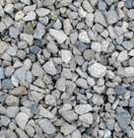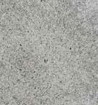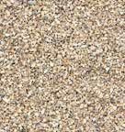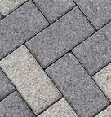

***your***

Tips a nd t r ends f o r homeowners, buyers a nd s e ll e r s

Driveway Material Options

The driveway can significantly enhance your home’s curb appeal. Homeowners have several options when considering which materials to use, each offering its own set of benefits. Here’s a look at the five most popular types of driveway materials.

iStock.com/Igor Paszkiewicz, kyoshino, vuk8691, waleed ahmed, MrDannyD

long-lasting. They can withstand heavy loads and harsh weather

conditions, making them a popular choice for many homeowners.

**Gravel:** Gravel is a budget- friendly option that

allows for excellent drainage, making it ideal for areas with heavy rainfall. While gravel driveways are easy to install, they

require frequent mainte- nance to prevent ruts and keep the gravel in place.

**Pavers:** Paver driveways offer a high-end look with many design possibilities. Made from materials like brick or stone, they are

durable and can be easily repaired by replacing individual pieces. However, pavers tend to be more expensive and labor- intensive to install.

**Crushed stone:** Crushed stone driveways are sim- ilar to gravel but have a more uniform look. They offer excellent drainage and flexibility in design, though they can become uneven over time without regular upkeep.

**Asphalt:** Asphalt drive- ways are another durable option, typically more

affordable than concrete.

They offer a smooth surface and perform well in cold climates.

However, asphalt requires periodic sealing to main- tain its appearance and prevent cracking.



Buying or selling a home can seem like an overwhelming task. A Certified Residential Specialist (CRS) can make the process easier—and more profitable. A CRS, with years of experience and success, will help you make smart decisions in a fast-paced, complex and competitive marketplace.

To earn the CRS Designation, residential real estate specialists must demonstrate outstanding professional achievements— including high-volume sales—and pursue advanced training in areas such as finance, marketing and technology. Contact your CRS today!