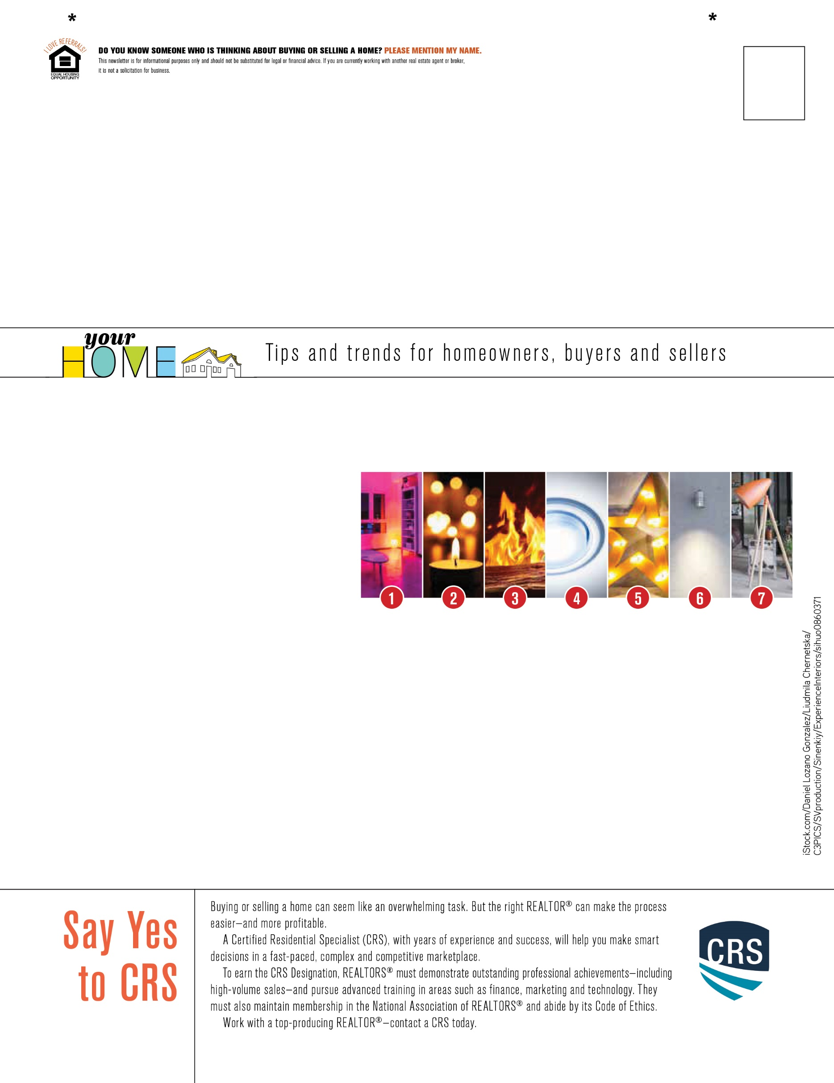

**1. Colorful lights**

Many people choose to put colored lights behind their mounted TV or around their entertainment centers.

**2. Candlelight**

Make your living room a relaxing place where you can go to improve your mood by adding some candles. You can mix assorted styles and scents to add some warmth to the room.

**3. Fireplace**

A fireplace can be a living room’s centerpiece, providing a gorgeous light source and warmth to the space.

**4. Recessed lighting**

With recessed lighting, you’ll be able to illuminate every bit of the room, as this provides more coverage area. If you don’t want to include it for the whole room, you could use recessed lighting just to brighten up a corner or to highlight artwork.

**5. Sculptural lighting**

Using a lamp that looks like a sculpture is an easy way to kill two birds with one stone. You’ll get a beautiful statement piece that completes the room while providing great lighting for your space.

**6. Wall lights**

There are an endless amount of wall lights to choose from for your home. They’re durable, long-lasting and usually easy to install.

**7. Oversized lamps**

An oversized floor or table lamp can be a bold and exciting way to introduce more light into a space. You can play with different lamp shapes, sizes, colors and materials.

**Y**

our living room is one area in your home

where you spend a lot of time hosting

and relaxing with your family and

friends. You want this space to be welcoming and cozy. Lighting can help you create the right ambiance for you and your guests. You can incorporate one or a combination of these great lighting styles.

Living Room Lighting