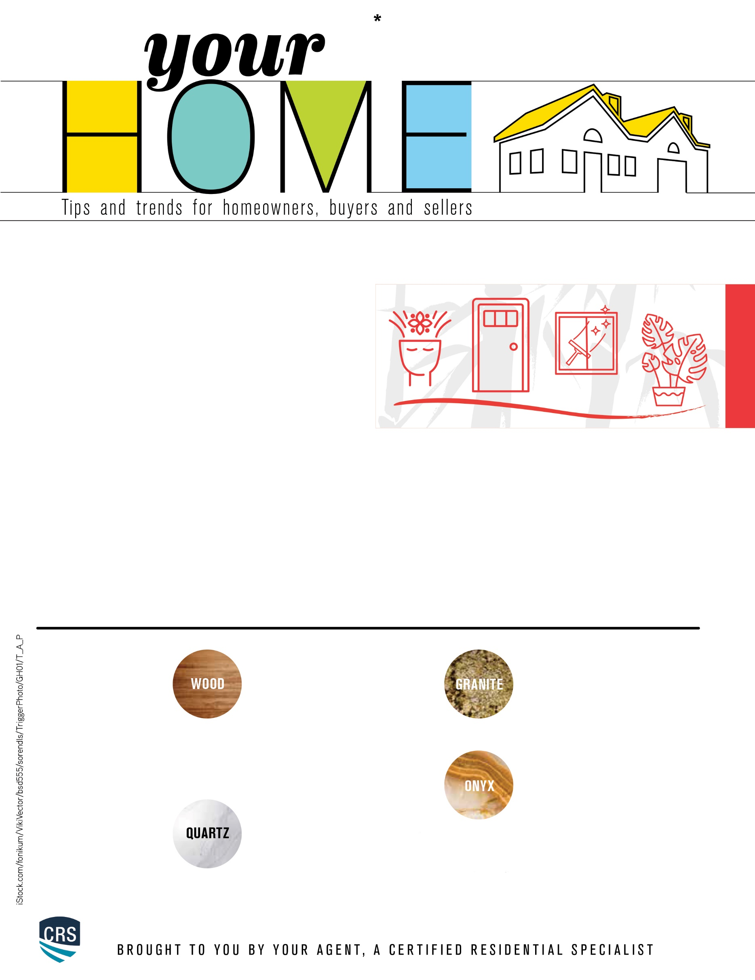

**Styles of Countertops**

Are your countertops starting to show wear and tear? Maybe they’ve suffered some structural damage. Or maybe there are stubborn stains you’re tired of seeing. Whatever the reason, replacing your countertops is a great way to give your kitchen new life. Here are some countertop styles to consider.

**Onyx** — If you’re looking for something

that will brighten up your space, you

may want to consider investing in onyx

countertops. They come in light, pastel

color options and can have a variety of

patterns. Each onyx countertop is unique, and they have a lifespan of up to 100 years. They can also be cleaned with just soap and warm water, as opposed to other natural stones that require specific kinds of cleaners that can be expensive.

**Granite** — Granite countertops are a

popular choice because they’re eye-

catching, affordable and last nearly

forever. With the appropriate sealing, t

hey will be moisture-, heat- and stain-

resistant.

**Quartz** — If you’re looking for

something beautiful and low

maintenance, a quartz countertop

may be the best option for you. They

are stain-resistant, easy to clean and

very durable. Because they have a nonporous surface, they don’t require sealing like some other natural stones.

**Wood** — Butcher block countertops

can often be purchased locally and

won’t break the bank. To keep them

in the best condition, you will have to

seal them regularly—otherwise

moisture will cause damage. When

sealing your wood countertops, be sure to use mineral oil, butcher block wax, polyurethane or a food-safe penetrating sealer.

eng shui is the practice of creating balance with the

natural world by arranging the objects and furnishings

in a living space. The words “feng” and “shui” are Chinese and translate to “wind” and “water,” respectively. It’s a philosophy that emerged from an ancient poem that reflects upon the way in which human life is connected and flows with the environment around it. Creating good feng shui in your home will give you more control over the energy that you welcome into your life.

**F**

**Clean and open the windows** — The windows of your home represent the eyes of the adults and voices of the children who live there. Make sure that your windows are cleaned regularly, as that will ensure as much sunlight is let in as possible.

**Add plants to your space** — Welcoming more plants into your living space will improve your overall life energy. Plants attract good luck and bring prosperity into your home. Some plants that promote good feng shui are money trees, rubber plants, snake plants, ficuses and hedgehog aloe.

**Commanding position** — This is one of the most important principles of feng shui. It’s essential that your bed, desk and stove are in the commanding position, as they represent your life, career and wealth, respectively. These objects should always be facing the entry door, as doors are portals of which energy comes into your life.

**Make more space** — Creating feng shui isn’t just about eliminating clutter. It’s more about letting go of what’s no longer necessary. Once you do that, you will have more room available to welcome what’s beneficial into your life as it comes.

Creating Good Feng Shui