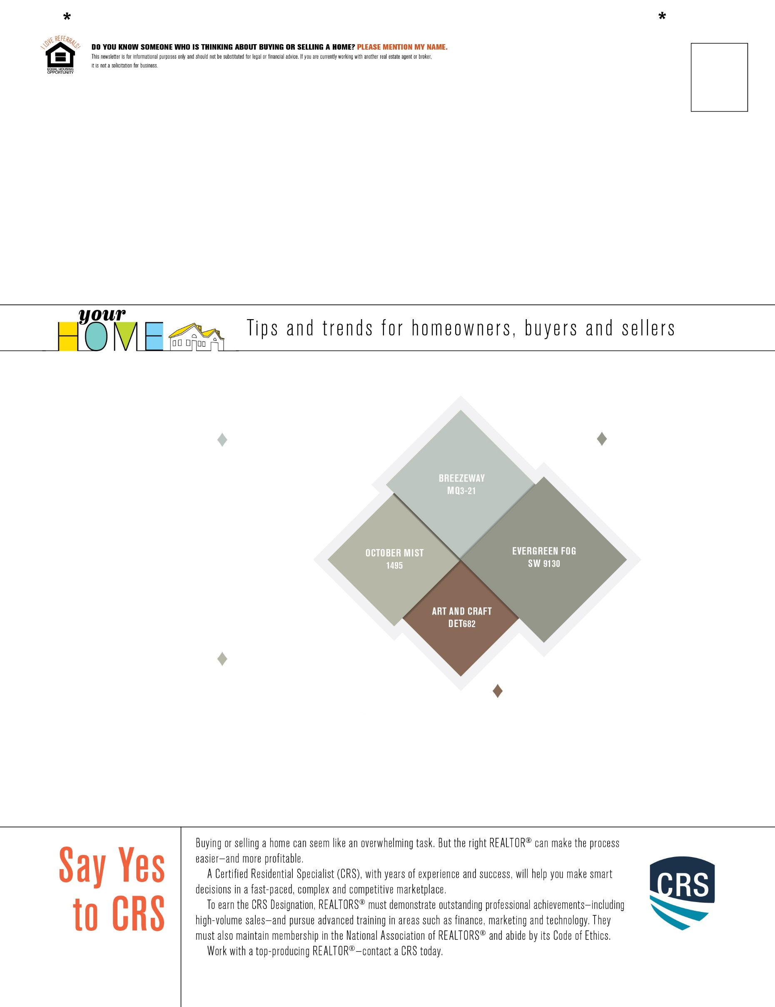

**Sherwin-Williams — Evergreen Fog**

Sherwin Williams’ Evergreen Fog SW 9130 is another

organic soft gray-green.

This color would be great

for a living room space,

inviting a refreshing

and therapeutic

spirit into the room.

Warm earth-toned

decor and accessories will

best compliment the color.

Paint Colors for 2022

**Dunn-Edwards — Art and Craft**

Art and Craft DET682 is a warm, rich and mature shade of brown. In a press release, the brand said that the color “signifies stability, comfort and calm”—all necessary things we need after the past two years.

**Benjamin Moore — October Mist**

A soft, silvery sage green called October

Mist 1495 is Benjamin Moore’s choice for

this year. This green sets the foundation for the retailer’s entire 2022 color palette, composed of 14 nature-inspired pigments. This color would be best in spaces where creativity will be cultivated, like an office space or the kitchen.

**Behr — Breezeway**

Behr opted for a beautiful blue-green shade called Breezeway MQ3-21. The color is reminiscent of crystal-clear ocean

water on a beachside vacation. It would

go well in any room, depending on which accent colors you pair

it with.

Each year, major paint brands release their color of the year, meant to predict the colors that illustrate and symbolize the year ahead. Some retailers began revealing their 2022 colors as early as October 2021. There were a lot of greens and natural hues selected for the year, and all of the color selections have a common theme of nature, calmness and buoyancy. Here are a few of the hues picked by some top names in paint. Which of these 2022 colors feel right to you?