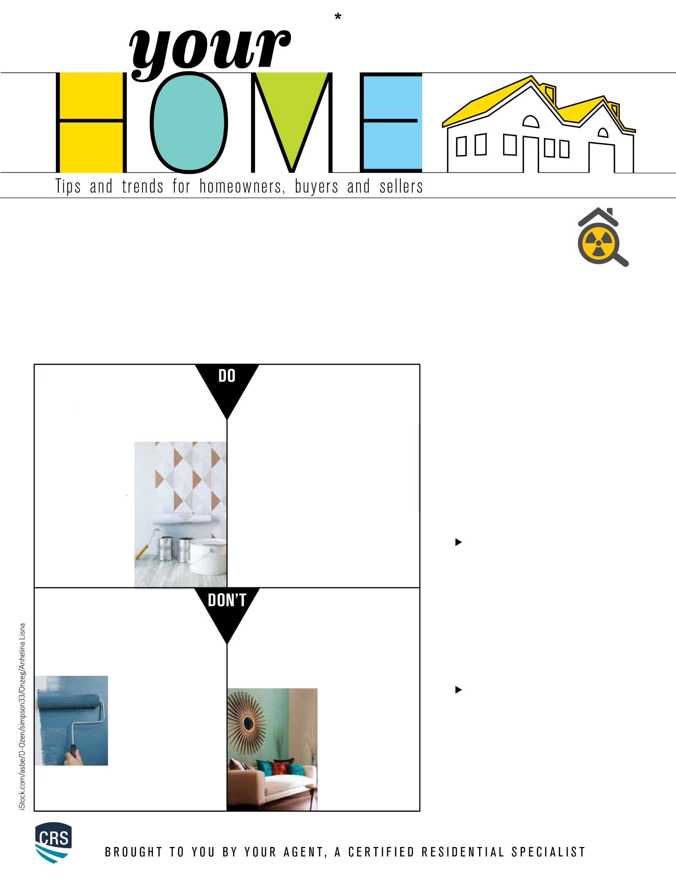

The Dos and Don’ts of Accent Wall Design

**Removing Radon**

**From Your Home**

Radon is a naturally occurring,

radioactive gas that has no color,

odor or taste. The gas can sometimes

find its way into your home; however, it’s best to keep those levels as low as possible, as exposure to it may cause adverse health effects.

The only way to determine the radon levels in your home is to test. Technology has advanced to the point where most homes with elevated radon levels can be properly treated. The Environmental Protection Agency (EPA) recommends that homeowners reach out to a qualified professional for testing. If your test results show a level of 4.0 pCi/l or higher, the EPA recommends professional radon mitigation.

Here are the most common ways to eliminate radon from your home.

The passive method of radon mitigation consists of sealing any obvious entryways, such as cracks in the foundation, gravel crawl spaces and groundwater sump pump pits. Experts have found that simply sealing and caulking these cracks in the foundation of your house is an inadequate technique on its own. Sealing is much more effective in conjunction with other mitigation methods.

Active Soil Depressurization (ASD) is the most common way to reduce radon levels. During this process, a sub-slab ventilation system is installed. The radon is ventilated underneath the building using pipes and fans before it reaches the inside. The passive method is usually done after the ASD is completed.

60% of the room is the dominant color, 30% is the secondary color and 10% is an accent color. For the accent color, choose something that’s completely different than the dominant and secondary colors to make it pop.

**Do give wallpaper or contact**

**paper a try Don’t be afraid of**

**bold colors and patterns**

Lively colors and unique patterns are what make accent walls special, so don’t shy away from them. Follow the 60-30-10 rule:

that outdated floral wallpaper in your grandmother’s bedroom—wallpaper these days is much more stylish, and there are endless design options for you to choose from.

**Do give wallpaper or   
contact paper a try**

Wallpaper is durable, easy to   
maintain and relatively simple to install. And we’re not talking   
about

should be mostly uninterrupted and rectangular. You’ll want minimal obstruction from windows and doors, unless they provide symmetry to the wall.

**Don’ chose the wrong wall**  
 If you pick a solid color for your accent

When deciding which wall you’d like to accent the room, it’s important that you choose the right one. You’ll want to go for the wall that naturally catches your attention when you enter the space. It should be mostly uninterrupted and rectangular. You’ll want minimal obstruction from windows and doors, unless they provide symmetry to the wall.

**Do add accessories**  
 If you pick a solid color for your accent

wall, you may want to add some artwork

to create a gallery wall. This will make the wall stand out and make even more of a statement. A big mirror centered on the accent wall will look nice, too, depending on the purpose of the room.

An accent wall’s main function is to provide contrast to a space. It’s an easy and affordable way to express yourself and breathe life into a room. It will look great just about anywhere in your home—if you do it right. Here are some general rules to keep in mind if you’re considering adding one.