*
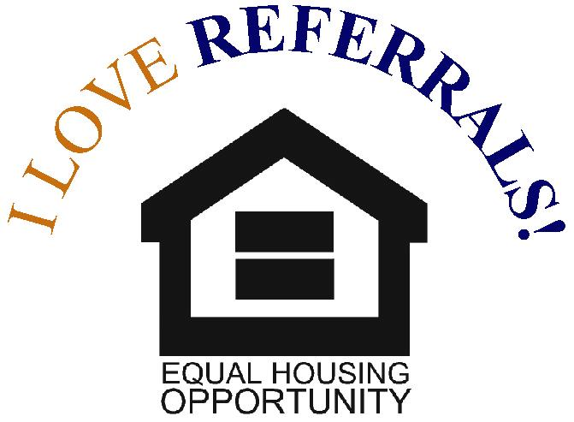


Why Switch to
LED Lighting?

More people are making the switch from traditional lighting to LED lightbulbs. Here are a few reasons you should join the movement.

LEDs provide a higher-
quality lighting.

LEDs last much longer than alternative lightbulbs.

Because you’ll be saving energy, you’ll also be saving money.

They’re a green solution that helps the environment.



You are helping to reduce your home’s carbon footprint. Due to their high
efficiency, these lightbulbs waste up to 5% less energy than other bulbs. LED lightbulbs also contain no mercury or any other hazardous material. Since you’ll have to replace LEDs less often, your household will create less waste.
You’ll see a dip in your electric bill when you make the switch. You’ll
also have to buy lightbulbs much less often—depending on your daily energy use, LEDs can last for decades.
The typical incandescent lightbulb will last for about 1,000 hours.
Fluorescent lightbulbs are more efficient, lasting from 7,000 to 25,000 hours, depending on frequent switching. LEDs have both options beat, lasting for up to 60,000 hours.
They will fill your home with enhanced ambient
lighting. The light they provide will also be whiter and closer to natural lighting.




Buying or selling a home can seem like an overwhelming task. But the right REАLTOR® can make the process easier — and more profitable.
А Certified Residential Specialist (CRS), with years of experience and success, will help you make smart decisions in a fast-paced, complex and competitive marketplace.
To earn the CRS Designation, REАLTORS® must demonstrate outstanding professional achievements — including high-volume sales — and pursue advanced training in areas such as finance, marketing and technology. They must also maintain membership in the NАTIONАL АSSOCIАTION OF REАLTORS® and abide by its Code of Ethics.
Work with a top-producing REALTOR®—contact a CRS today.

Say Yes
to CRS

