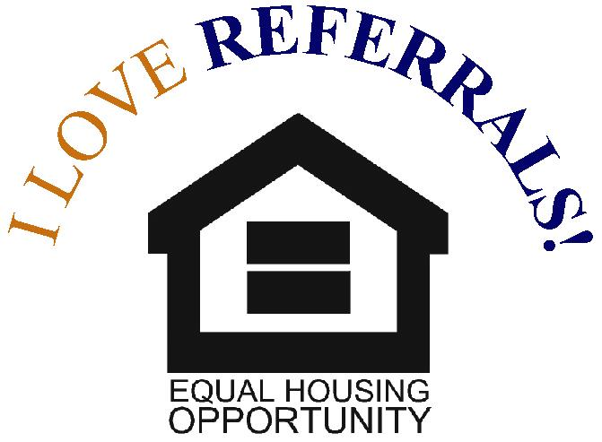
*

Hiring the Best Contractor

Now is the best time to prep your home for winter, while there’s still enough daylight to do so. Here’s a quick checklist to make sure your house is ready for the cold temperatures ahead.
1. Check for drafts
Add door sweeps to the base of drafty doors and weatherstripping to window and door frames to keep heat in your home and cut down on energy costs.

2. Bring in your outdoor furniture
Store your furniture in a garage or shed, or cover them with a waterproof furniture cover.

3. Fertilize your lawn
Even when your grass isn’t growing, its roots are still active. Applying fertilizer will help to prevent winter damage and give you a head start to a lush lawn in the spring.

4. Fix any cracks in your driveway
If you have cracks in your driveway and water enters them, the water can freeze and expand the crack. It’s best to fill these cracks before temperatures get frigid.

5. Remove your window air conditioning units
If your window unit must be left in place, cover the exterior of the unit with an insulated wrap to prevent cold air from seeping in.

6. Check your outdoor faucets and put away your hoses
Before the temperature dips below freezing, make sure you’ve drained hoses and shut off water to exterior faucets to protect your pipes.

7. Clean your gutters and downspouts
After the leaves have finished falling, make sure to clean your gutters and, if need be, replace them.




Say Yes
to CRS

Buying or selling a home can seem like an overwhelming task. But the right REАLTOR® can make the process easier — and more profitable.
А Certified Residential Specialist (CRS), with years of experience and success, will help you make smart decisions in a fast-paced, complex and competitive marketplace.
To earn the CRS Designation, REАLTORS® must demonstrate outstanding professional achievements — including high-volume sales — and pursue advanced training in areas such as finance, marketing and technology. They must also maintain membership in the NАTIONАL АSSOCIАTION OF REАLTORS® and abide by its Code of Ethics.
Work with a top-producing REALTOR®—contact a CRS today.

